For Windows: Failed trail

Drive 1- USBB

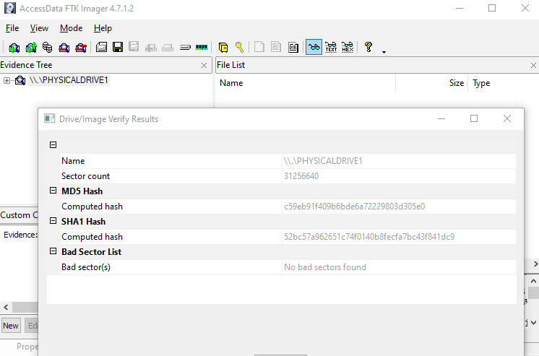

Drive 2 USBA

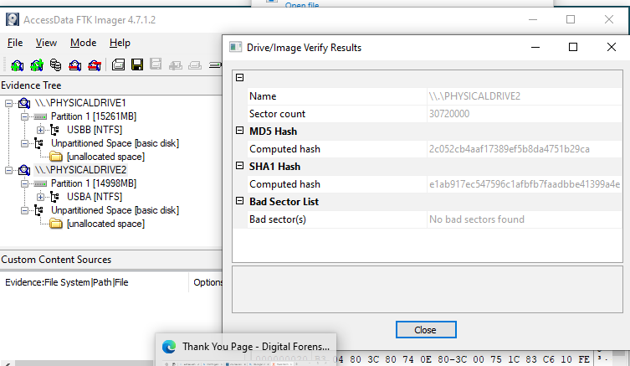

After copying the file to usbA:

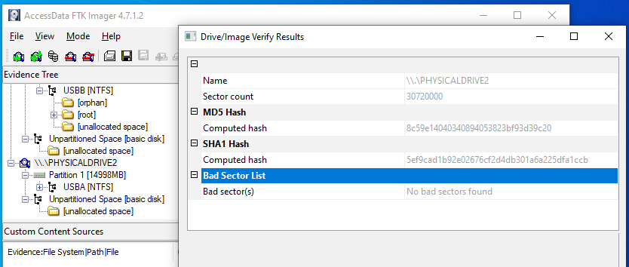

Making usbA readable: I used diskpart to do it.

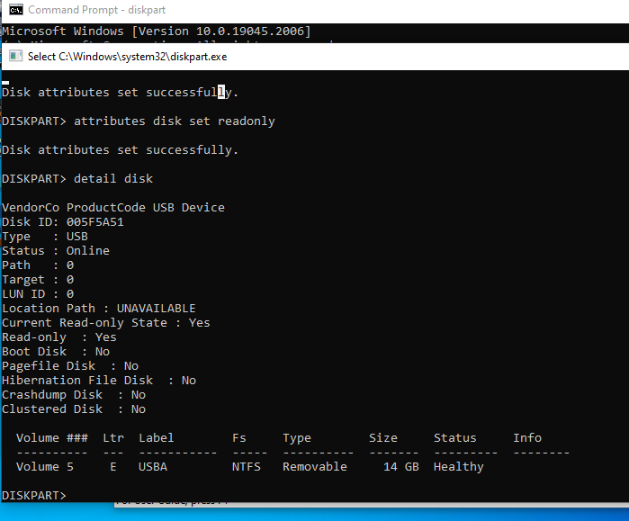

Cloning to usbb now:

Part-1

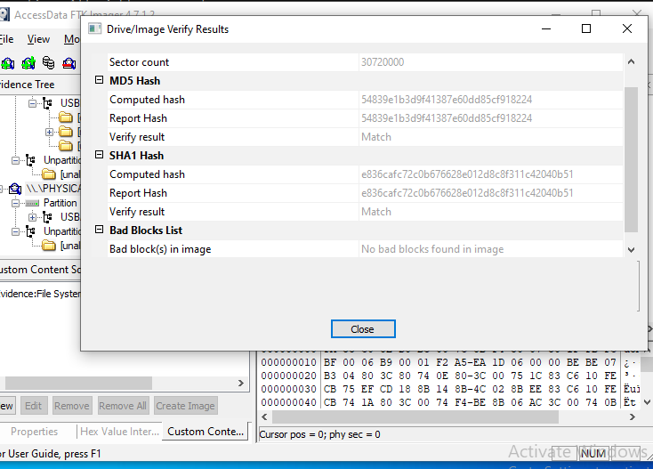

After copying the hash value

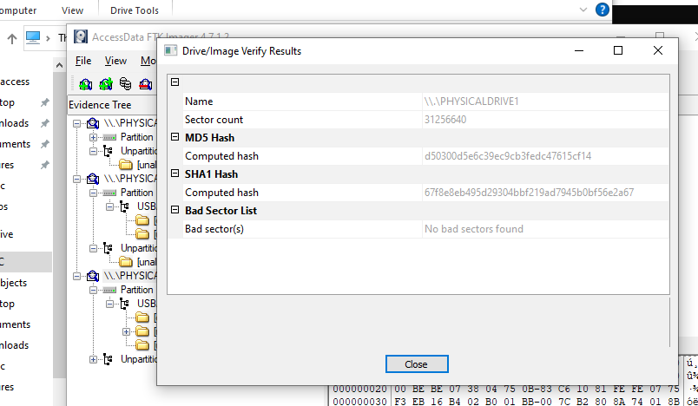

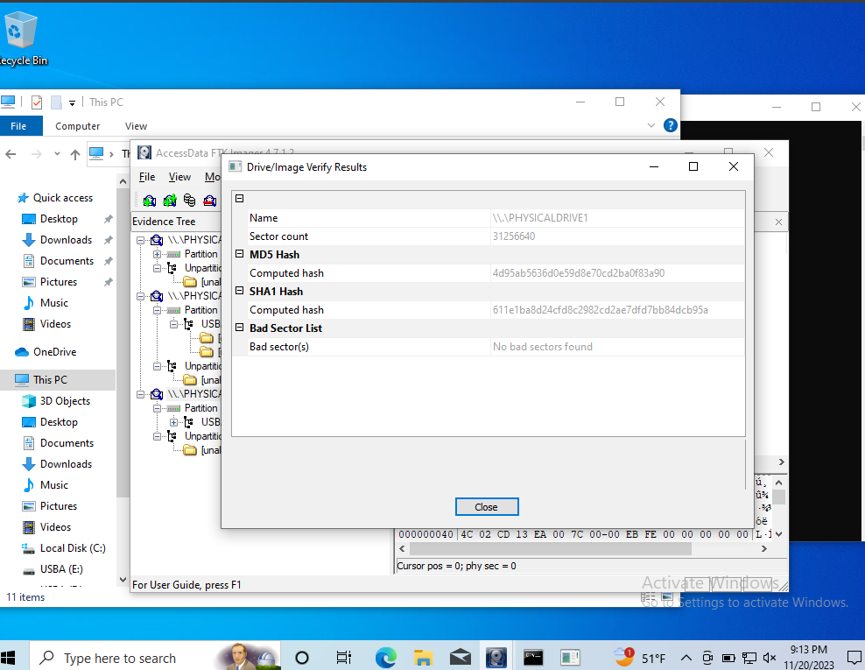

Result Failed to get the hash values same:

Try Nth time:

Using 7zip – check sum of drives with no data:

USBA- drive F

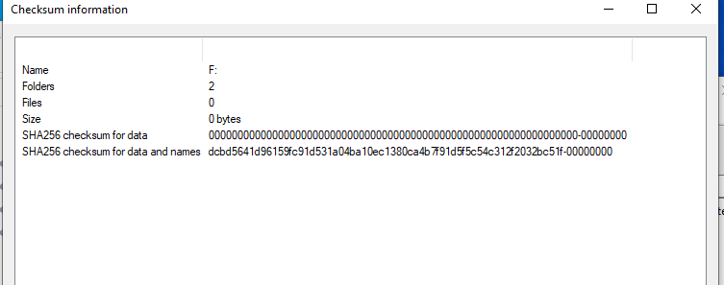

USBB- drive G

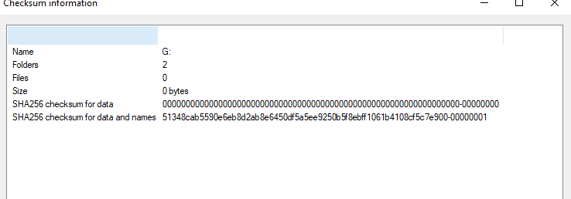

Adding the text file and doing check-sum

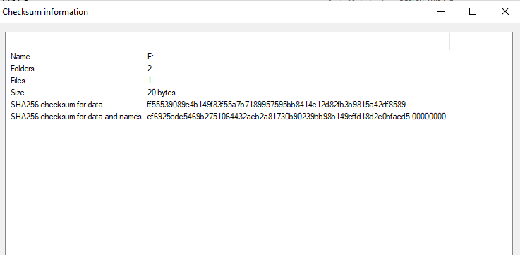

Making it write protected using diskpart

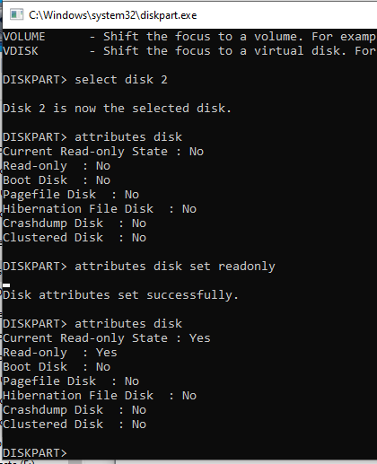

Cloning it



Trying to check the hash after cloning:

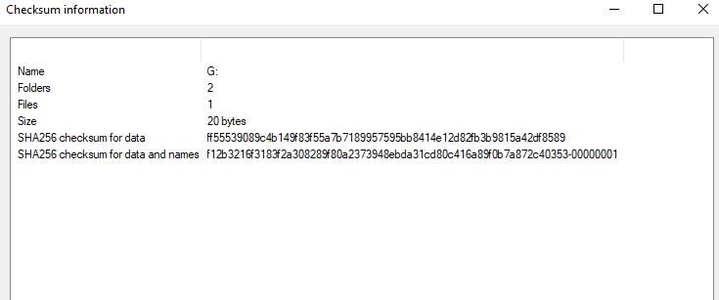

Done and dusted

Result: Got the hash values same before and after cloning.

For Linux (Not Kali Linux): Parrot OS

SHA-256 Hash of USB A and USB B:

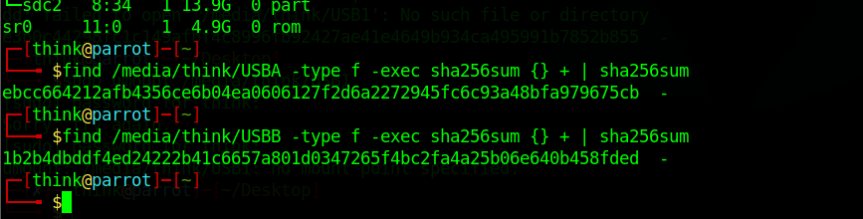

They are formatted and both are empty.

Full block scan result

1.

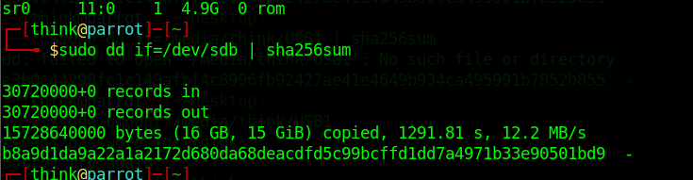

2.

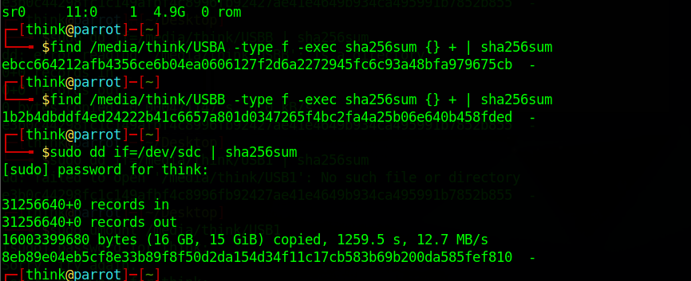

After creating the file and making it one USB read only.

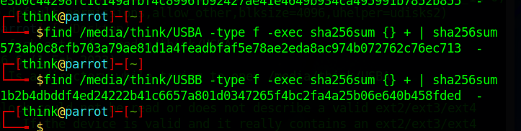

Full disk hash value after :  
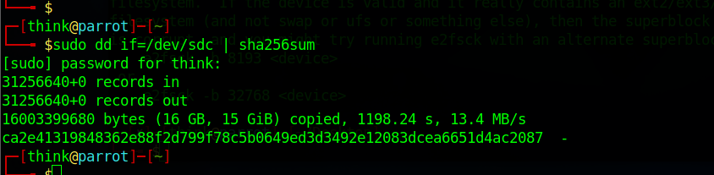

Installing clonezilla

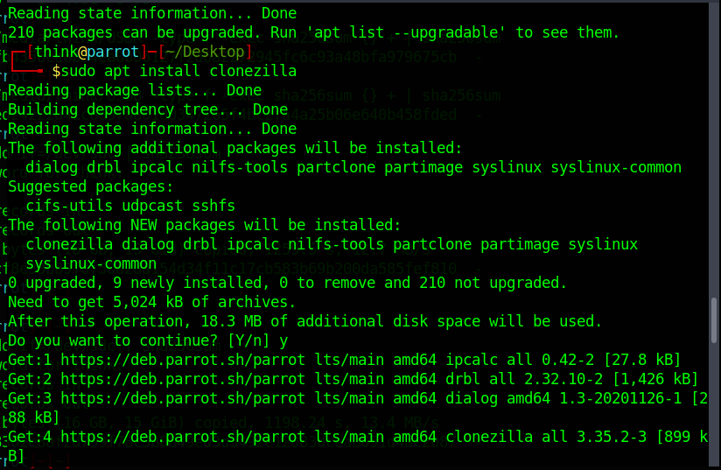

NoteL sdb has no data and sdc has the file-we need to clone

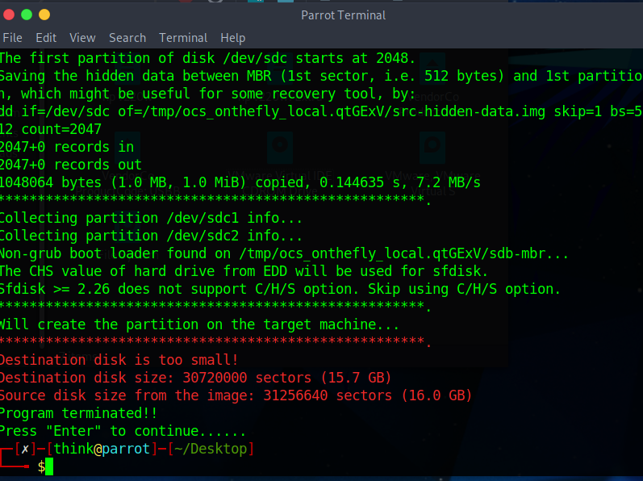

Getting error now trying to reverse drives,

Changed required settings and file permissions as required:  
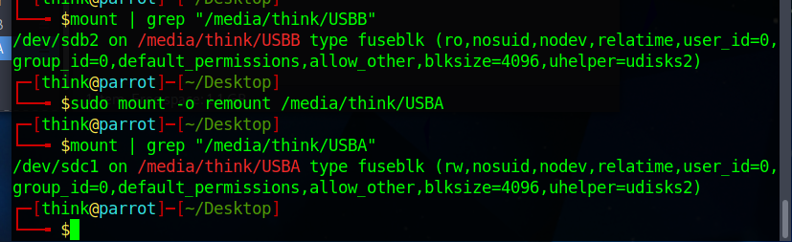

Now directory has:

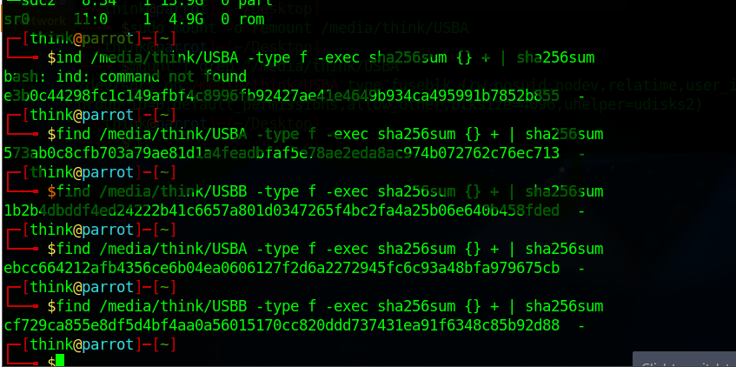

Full drive hash:

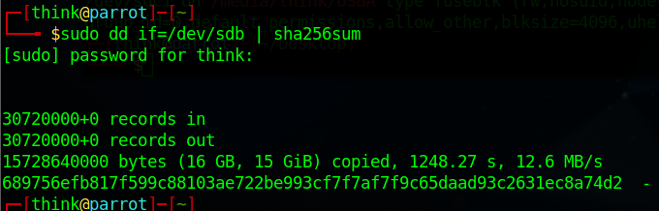

Now copying again using clonezilla

Sdb has data now

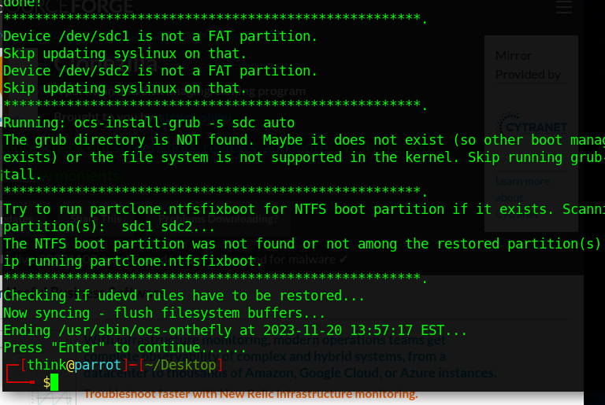

Now trying to calculate the hash value:

Disk we mad the clone:

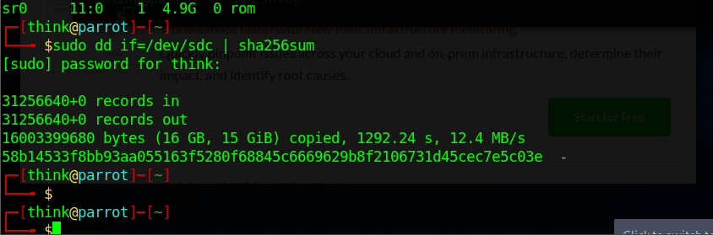

Disk we copied from:  
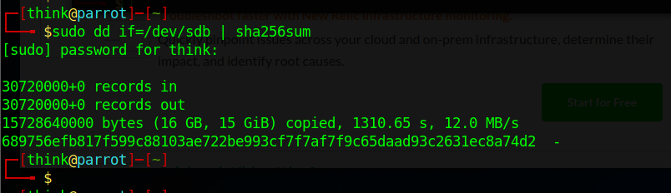

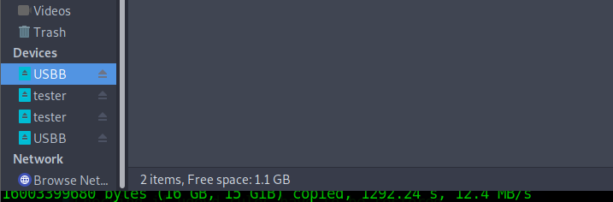

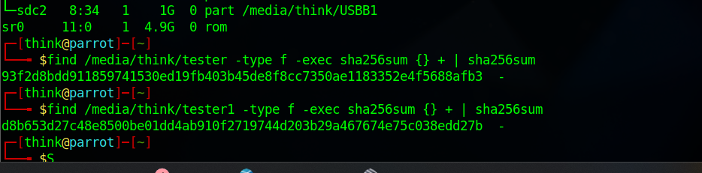

After copying:

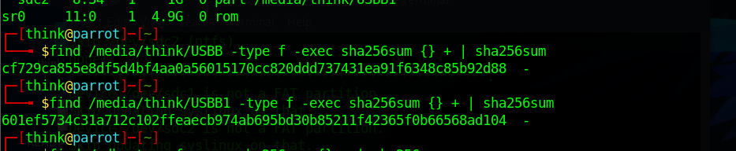

Using clonezilla, dd, find result: Couldn’t get the hash value same.

Trying Nth time:

Empty drives: Source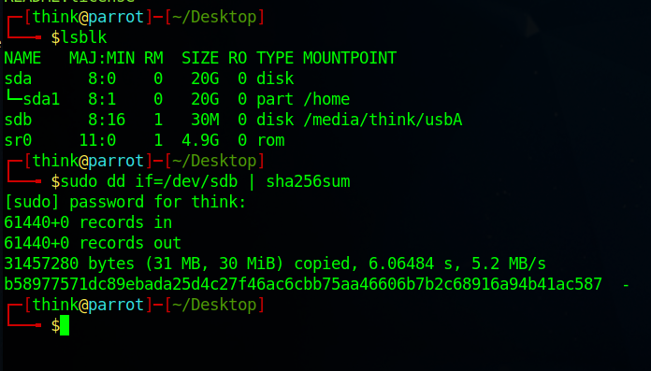

Destination drive

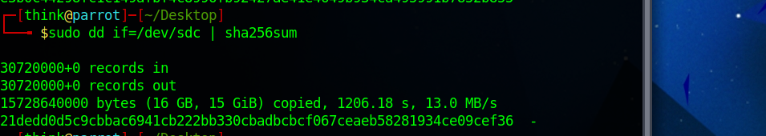

Now using find: when the file are empty

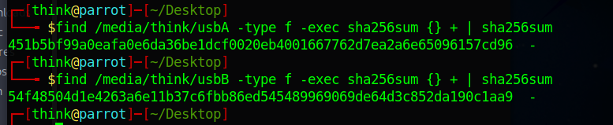

Sha value after adding the file:

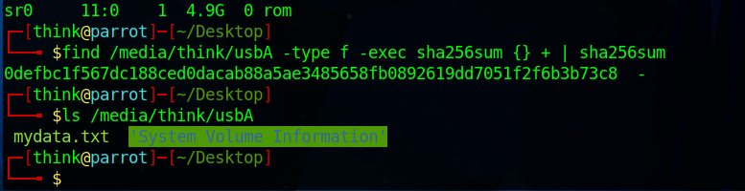

Making it write protect

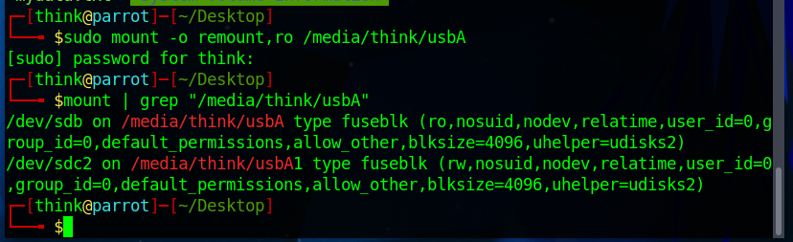

Cloning

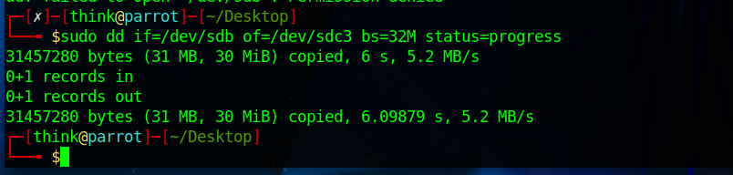

Trying to get the hash value

This is the has value with data with write protection

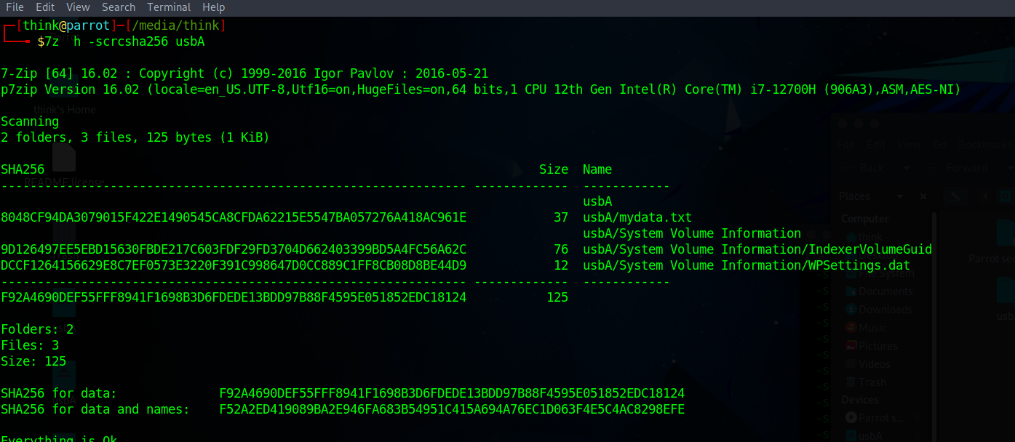

Data cloned drive hash value:

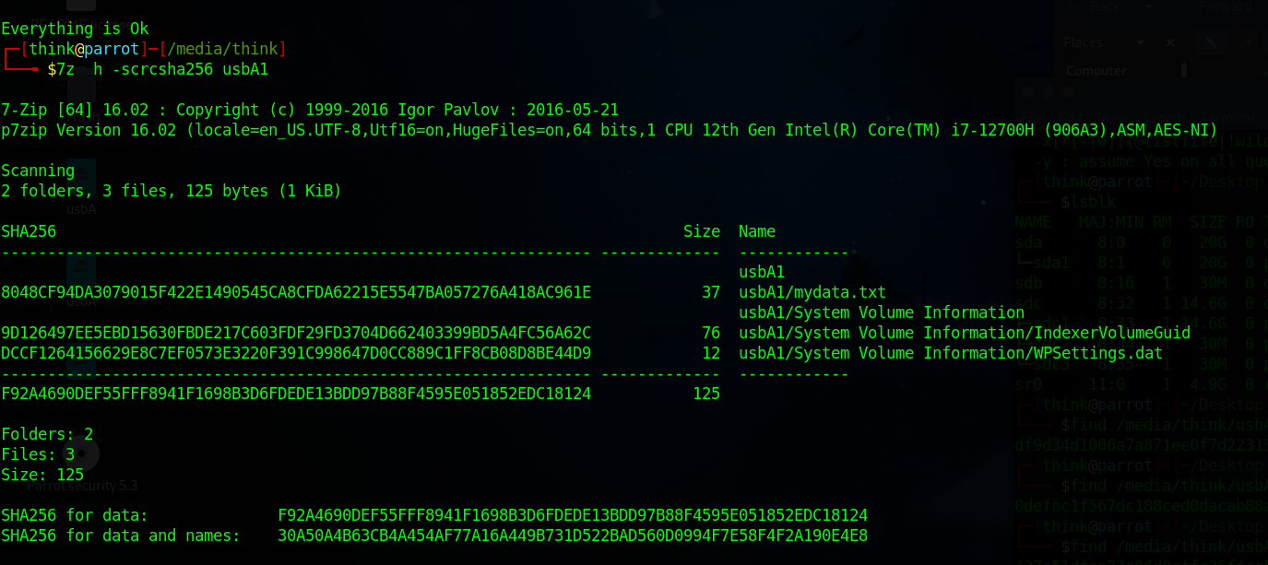

Result: got the hash values same before and after cloning using dd command.